Huỳnh Ngọc Quang – SE181838

NWC204 - dunglt92

## Access a Cisco Switch through the Serial Console Port

### Connect a Cisco switch and computer using a rollover console cable.

### Configure Tera Term to establish a console session with the switch.

## Display and Configure Basic Device Settings

### Display the switch IOS image version.

IOS: C2960-LANBASEK9-M

Version: 15.0 (2) SE4

### Configure the clock.

## (Optional) Access a Cisco Router Using a Mini-USB Console Cable

# 

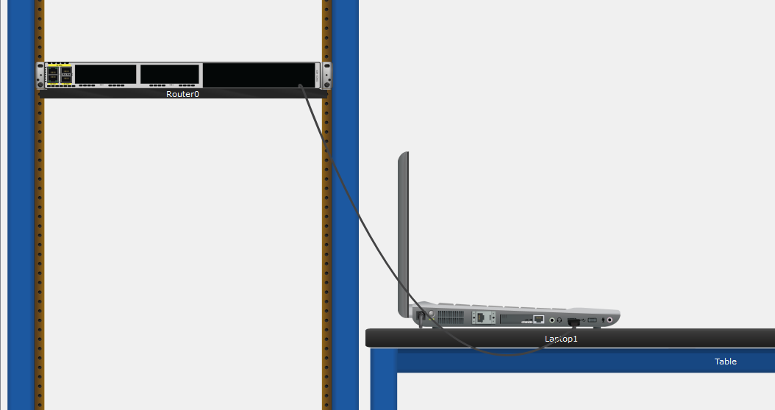

# Reflection Question

* 1. How do you prevent unauthorized personnel from accessing your Cisco device through the console port?
* Create login password in line configuration as well as set password in privileged access mode.
* Physically secure.
  1. What are the advantages and disadvantages of using the serial console connection compared to the USB console connection to a Cisco router or switch?
* The choice of connection method relies on the presence of suitable ports on both the PC and the router or switch. When a PC has a serial port and access to a DB9-to-RJ45 cable, it's generally simpler to establish a connection with the router or switch using the serial console port. In cases where the PC lacks a serial port, a third-party USB-to-Serial adapter can be employed. It's worth noting that Cisco switches do not feature mini-USB console ports, rendering USB connections unavailable. For those who frequently connect to a Cisco router equipped with a mini USB console port, this approach can be highly efficient once the Cisco drivers are installed, as most modern PCs come equipped with USB ports.